. , 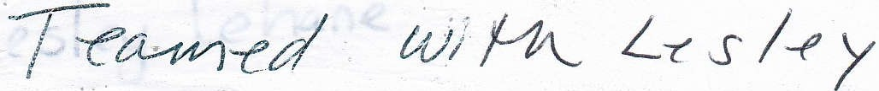

Phonemic Awareness

Phonics

0 fr:rdt
c l o �} rl

u { · ' ')
I
rf1J rltl.)

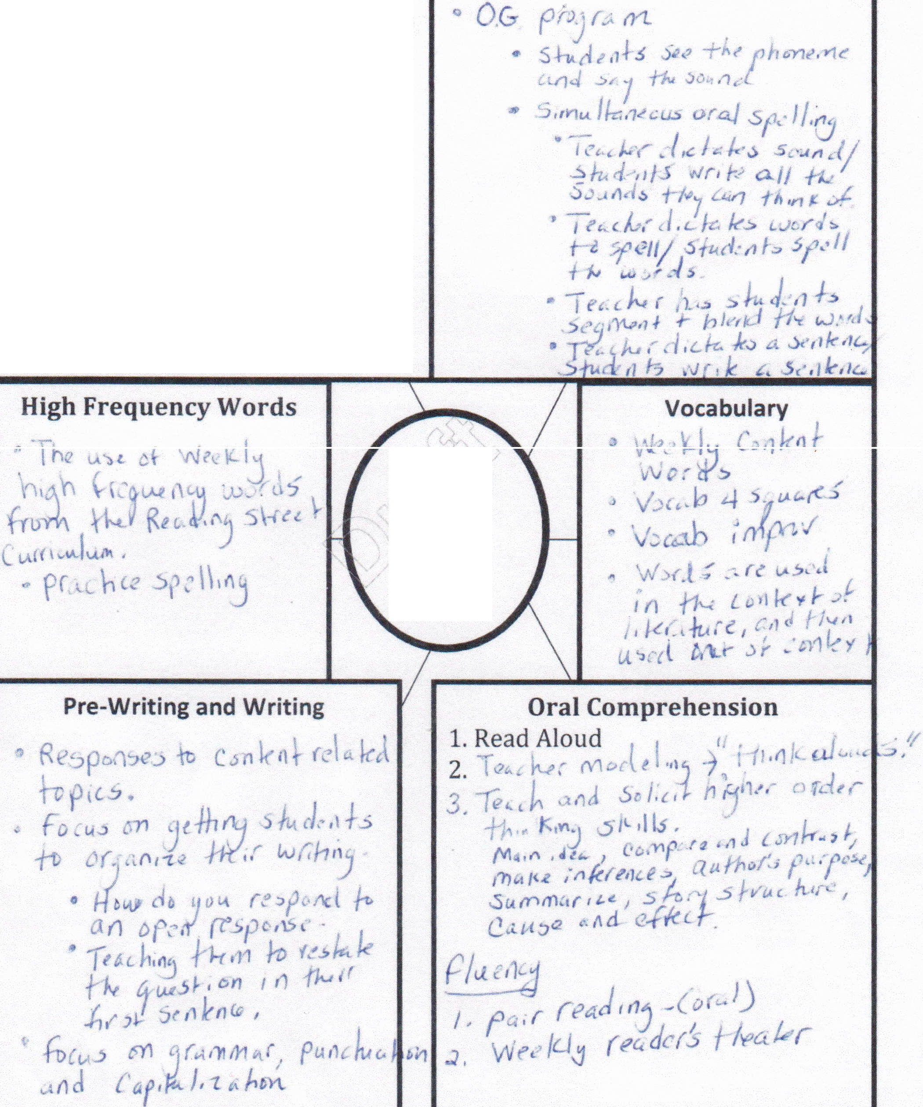
0 5t? J (YU '' 'j
G> P\ ·" (\ Jo'\'\
r_,p s ,J

Class
Clob

