Area 1
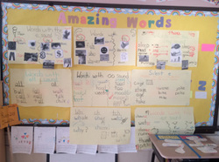
Description of Area: Word Wall

Purpose of Area: I turned this board from an Amazing Words to a Parts of Speech board. My students need more support in quickly decoding words; they keep their Amazing Words in their student dictionaries.

What do you want to reconsider: Organization? Content? How to make it kid friendly

Area 2

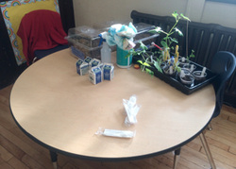
Description of Area: Table

Purpose of Area: This area serves as our breakfast table, Observing Area for Nature/Science projects, and a table where my paraprofessional and I work 1-1 with students.

What do you want to reconsider: How to make this area as multipurpose as possible.

Area 3

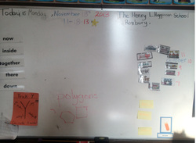
Description of Area: Front Board Area

Purpose of Area: To Display Information that students will need heavy exposure to at this point of the year. Changing the board to this allows me space to keep important information and still leaves me space to display my visuals and graphic organizers.

What do you want to reconsider: I need help sectioning the information so my board isn't so cluttered and able to distinguish from another visual display.

